Step 1: Add Your Text To The Image
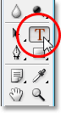
Select the Type Tool.
With your Type Tool selected and white as your Foreground color, go up to the Options Bar at the top of the screen and choose your font. Your choice of fonts will of course depend on which fonts you currently have installed on your system. I’m going to choose Helvetica Black Condensed for my font.
Add your type to the image.
Click the checkmark in the Options Bar to accept your type when you’re done:

Step 2: Resize And Reposition The Type As Needed With Free Transform
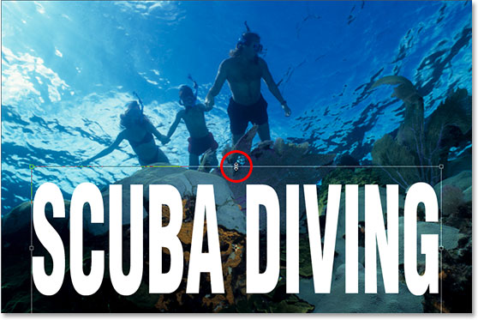
Move and resize the text as needed with Photoshop’s Free Transform command.
Press Enter (Win) / Return (Mac) when you’re done to accept the transformation.

Step 3: Lower The Opacity Of The Type Layer
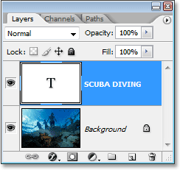
Photoshop’s Layers palette showing our two layers.
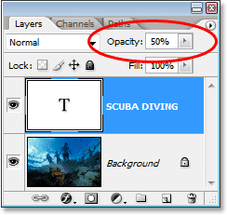
Lower the opacity of the Photoshop text layer to make the text more transparent.
And here’s my image after lowering the transparency of my text:
The text now appears semi-transparent after lowering its opacity value.
The text now appears even more transparent after lowering its opacity down to 35%.

This is one text effect, but we are going to do a few more steps and achieve a BETTER effect.
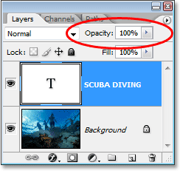
**Set the opacity value of the text back to a full 100%.

Step 4: Lower The "Fill" Value All The Way Down To 0%
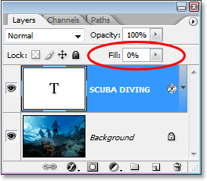
Lower the “Fill” value of your Photoshop type layer down to 0%.
The text has disappeared inside the image.

Step 5: Add An “Outer Glow” Layer Style
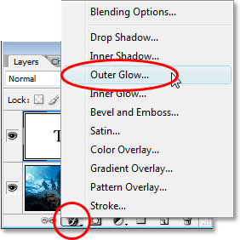
Add an “Outer Glow” layer style to the Photoshop type layer.
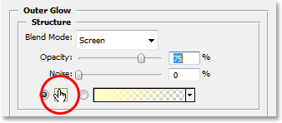
Click on the color swatch to change the color of the Outer Glow.
Click inside the image to sample a color to use for your Outer Glow.
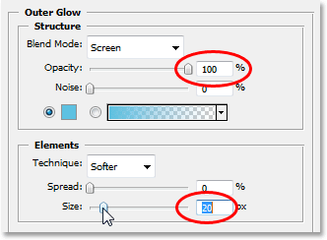
Increase the Opacity of the Outer Glow to 100% and increase the Size to around 20 pixels.
Click OK when you’re done to exit out of the Layer Style dialog box. Here’s my image so far:

Step 6: Set The "Fill" Value Back To 100%
Go back up to the top right corner of the Layers palette and set the type layer’s Fill value back to a full 100%:
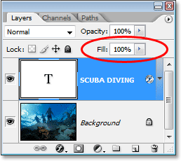
Set the Photoshop type layer’s Fill value back to 100%.
This is going to temporarily fill your text with white again:

Step 7: Change The Type Layer’s Blend Mode To “Overlay”
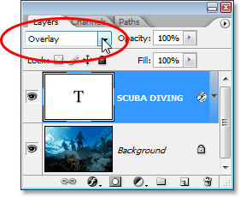

If you find that the Overlay blend mode is too intense with your image, try “Soft Light” instead, which gives the same yet much more subtle effect.

Step 8: Add An “Inner Glow” Layer Style To The Type
Click back on the Layer Styles icon at the bottom of the Layers palette and this time, choose Inner Glow from the list:
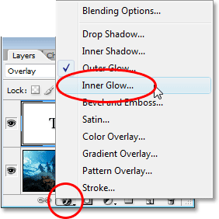
Add an “Inner Glow” layer style to the Photoshop type layer.
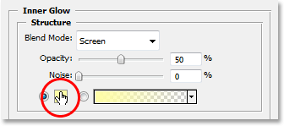
Click on the color swatch for the Inner Glow to change its color.
Sample a dark color from the image which will become an inner “shadow”.
:
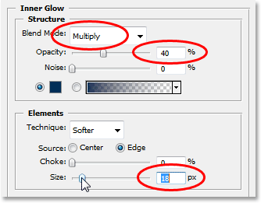
The final result.
And there we have it! That’s how easy it is to add transparent type to an image in Photoshop!

